Stackup
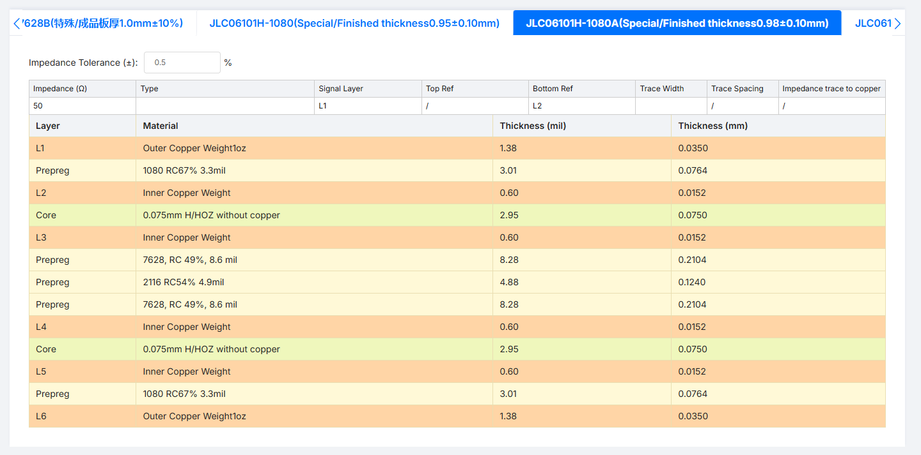

https://jlcpcb.com/pcb-impedance-calculator
Impedance (Ω) | Purpose | Type | Signal Layer | Top Ref | Bottom Ref | Trace Width | Trace Spacing | Impedance trace to copper
85 | Top Layer 85ohm… | Differential Pair (Non coplanar) | L1 | / | L2 | 4.08 | 4.2 | /
90 |  | Differential Pair (Non coplanar) | L1 | / | L2 | 4.05 | 5.5 | /
85 |  | Differential Pair (Non coplanar) | L3 | L2 | L5 | 4.03 | 5 | /
50 |  | Single Ended (Non coplanar) | L1 | / | L2 | 4.31 | / | /
48.88 |  | Single Ended (Non coplanar) | L3 | L2 | L5 | 4 | / | /

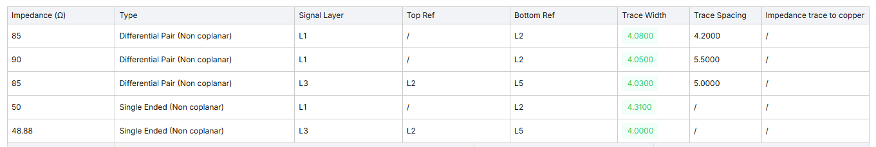

Protocol | Layer | Trace Width | Trace Spacing | Target Single | Target Diff
MIPI CSI, DSI | L1/L6 | 4.31mil | 6.4mil | 50ohm | 90ohm
USB 3.1, USB 2.0, SuperSpeed & PCIe, HDMI, DP, DDR4 Differential | L1/L6 | 4.02mil | 5.4mil | - | 90ohm
DDR4, RGMII, SDMMC | L1/L6 | 4.31mil | - | 50ohm | -
DDR4, RGMII, SDMMC | L3/L4 | 4.0mil | - | 48.88ohm

Protocol | Layer | Trace Width | Trace Spacing | Target Single | Target Diff
90ohm diff  50ohm single | L1/L6 | 4.31mil | 6.4mil | 50ohm | 90ohm
USB 3.1, USB 2.0, SuperSpeed & PCIe, HDMI, DP, DDR4 Differential | L1/L6 | 4.02mil | 5.4mil | - | 90ohm
DDR4, RGMII, SDMMC | L1/L6 | 4.31mil | - | 50ohm | -
DDR4, RGMII, SDMMC | L3/L4 | 4.0mil | - | 48.88ohm

For non-coplanar keep trace spacing between neighboring traces 3 times the width apart if measuring from the center. This means trace spacing would be equal 2x the trace width.

50ohm single ended non coplanar (top layer):

